**Setup Netbeans Project**

**Revision 1.00**

2018/09/07

1. **Introduction**

In order to be able to build and compile a Netbeans project, the project properties need to be setup correctly for it to work. This manual describes this process. It is important to note that for different versions of Netbeans, the manual will need to be adopted accordingly.

1. **List of requirements**

* Netbeans 8.1 or higher
* Inno Setup Compiler 5.5.9 or higher
* Netbeans project files
* Windows XP or higher

1. **Project Properties Setup**

* Open the Netbeans project and go to the Project Properties page
* Go to the Libraries category and make sure all the required libraries are found and listed

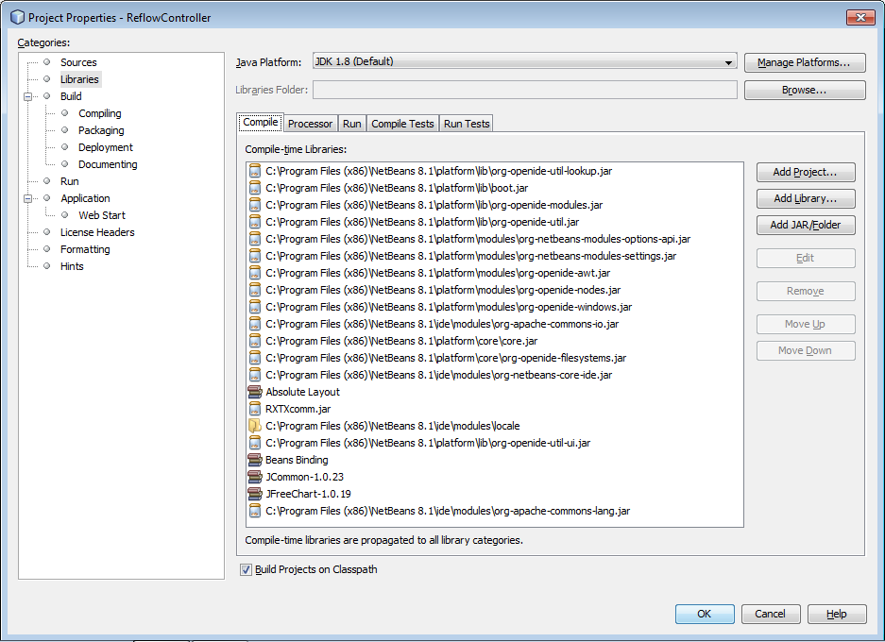

* Goto the Run category and ensure the correct working directory and VM Options is set else the project will not run

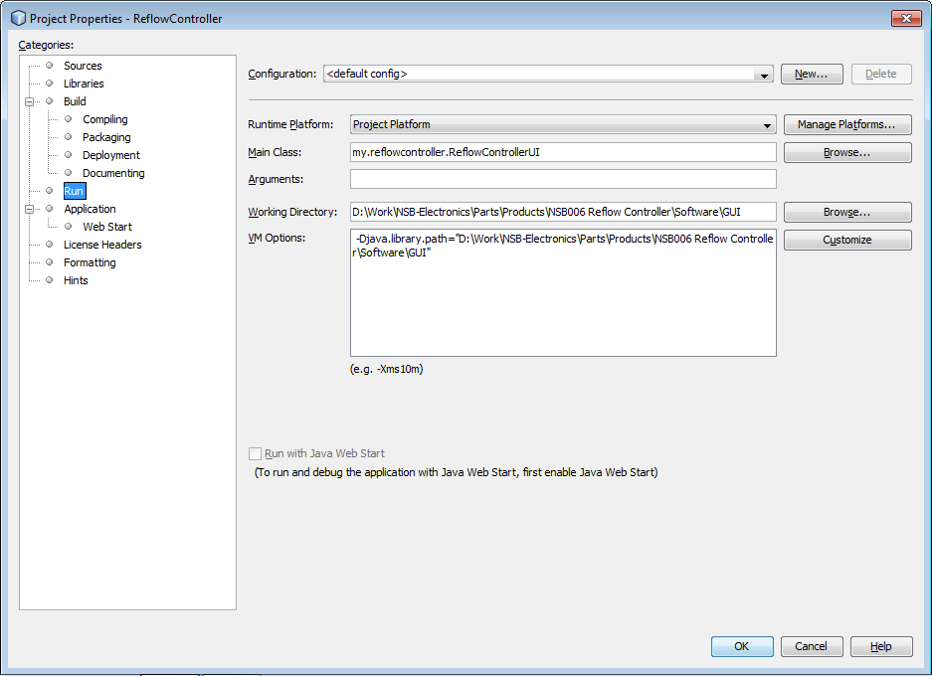

1. **Compile and Run Project**

Click on the Run icon or press F6 to run the project. If all the project properties were changed correctly, the GUI should open and run.

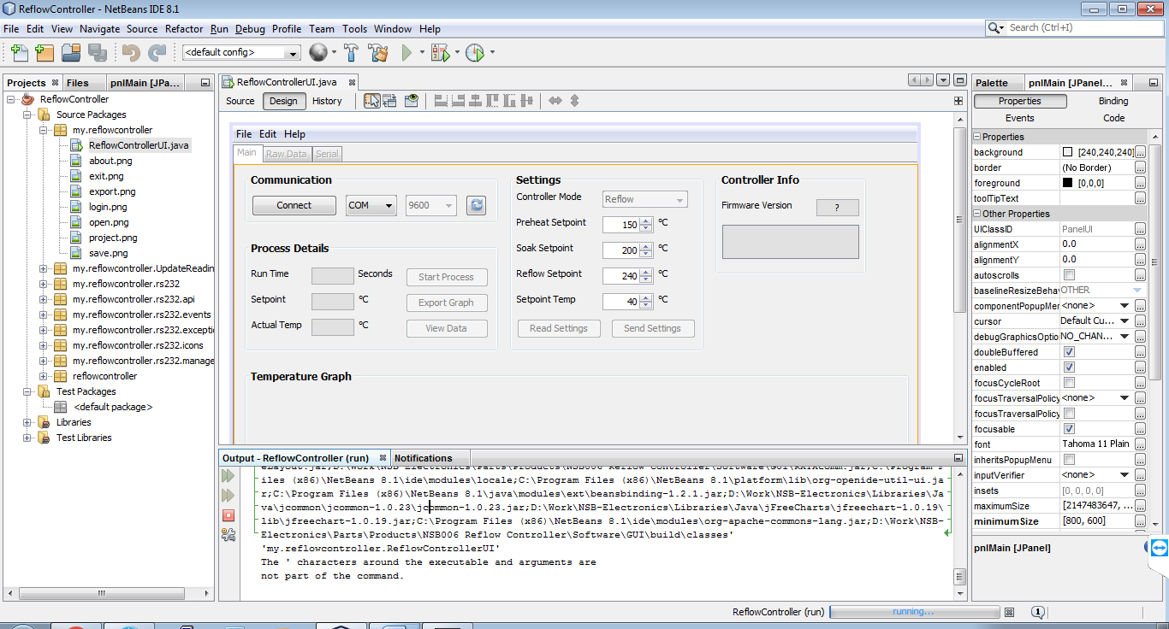

1. **Package Project**

Once the program has been tested and working, to package it, right click on the project name in the Project panel, select Package as -> Image Only. Wait for the process to complete and check any errors or warnings and fix.

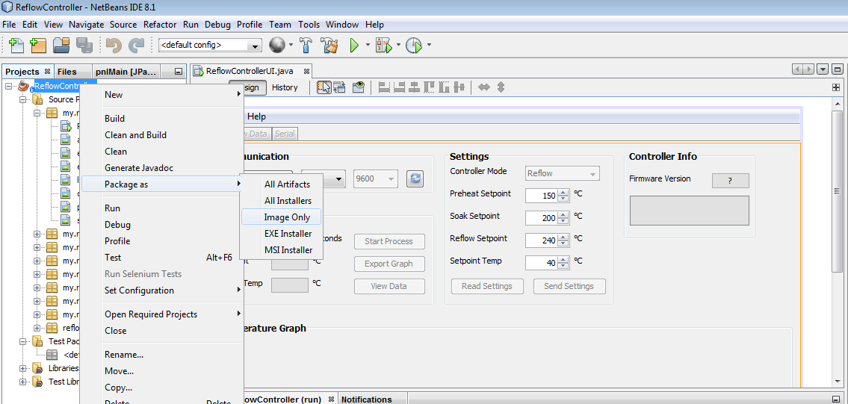

1. **Build Installer EXE**

Open Inno Setup and open the .iss file contained in the project folder under Inno Setup EXE sub-folder (this was setup for this project and can be adapted for other projects)

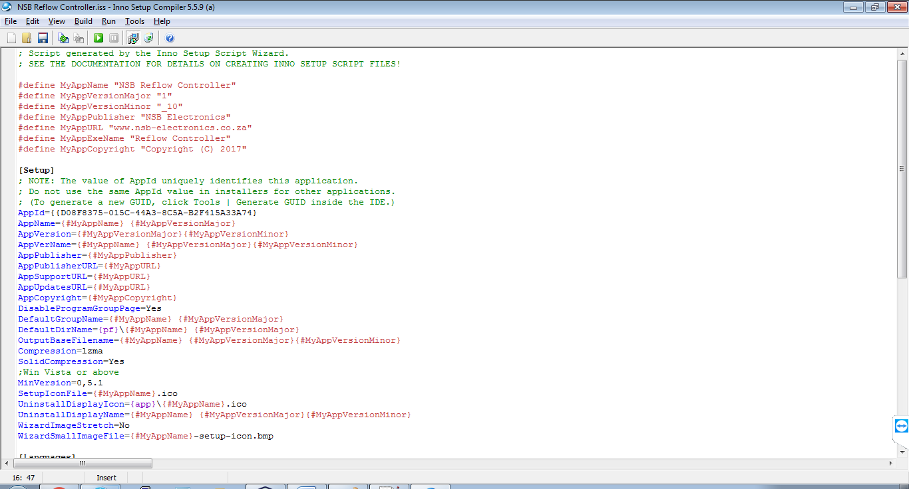

When changing to a new version, remember to set a new AppId. To generate the new AppId, move cursor to the line AppId and click Tools-> Generate GUID. Remove the old AppId if it remains there.

Note the double { in the front, must be like that

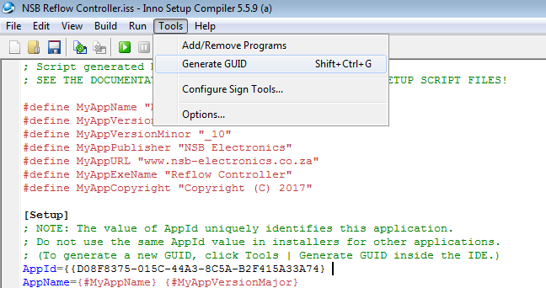

Once all the settings have been changed, compile the script by clicking Build -> Compile or Ctrl+F9.

When it has completed compiling, the installer exe will be ready and located in the Output folder within the Inno Setup EXE folder.